PDC Lab 4
Advait Deochakke
20BCE1143

1) Reduction
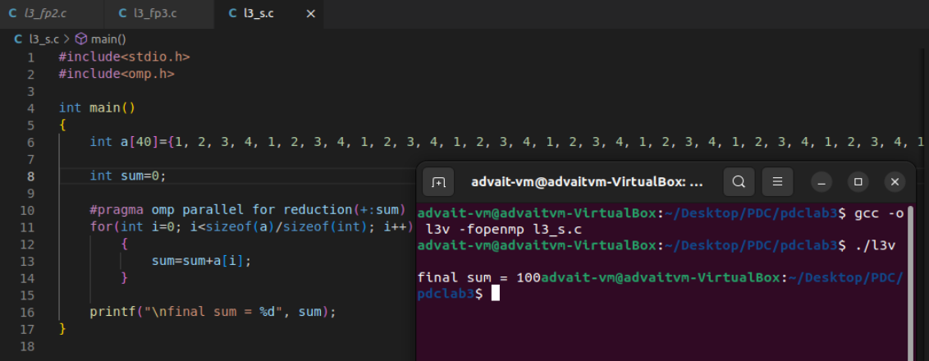
2) c=a+b; c=a-b

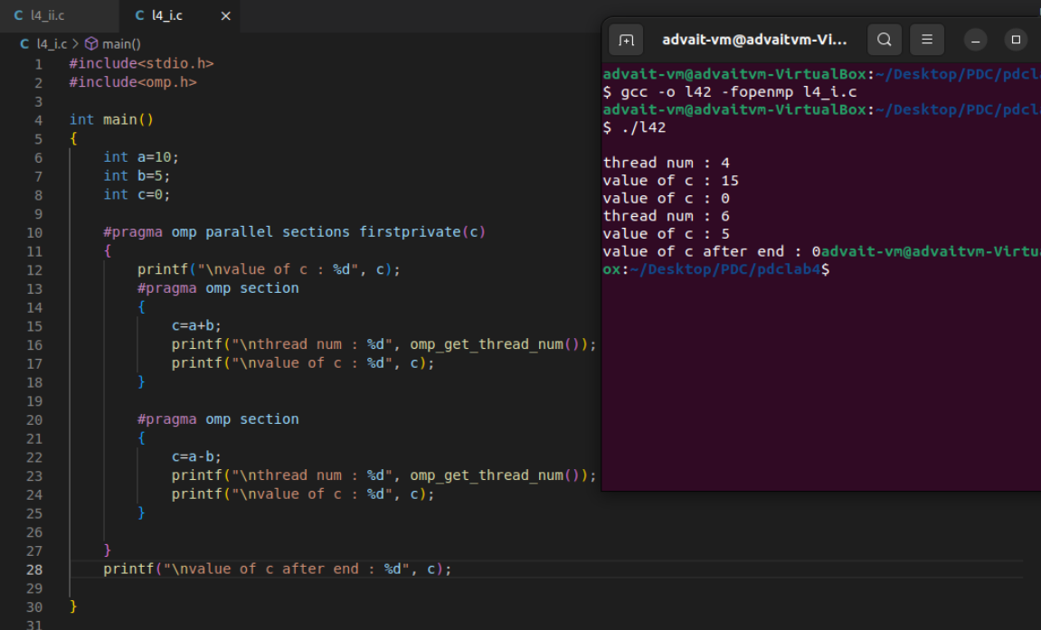

3) c[i]=a[i]+b[i]; c[i]=a[i]*b[i]; c[i]-b[i]

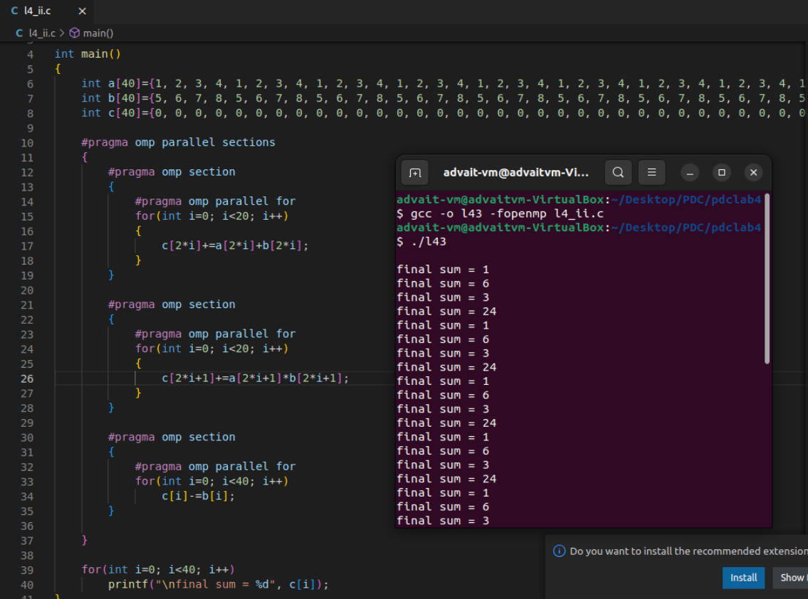

4) listing of prime nos <n

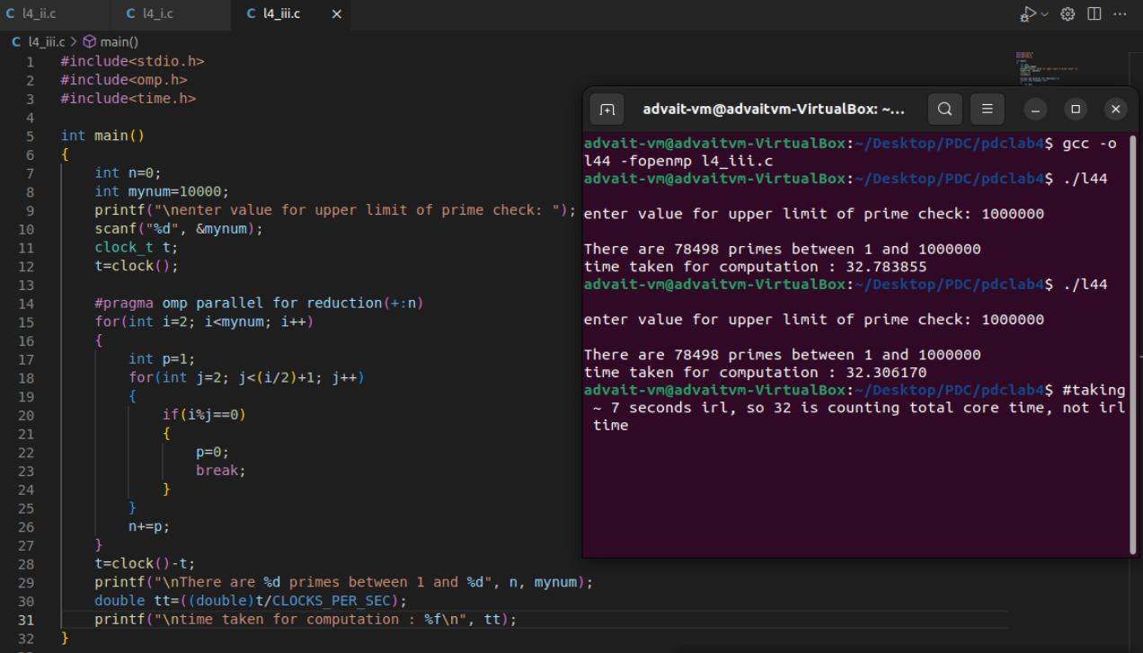

5) Sudoku solver (2x2x4)

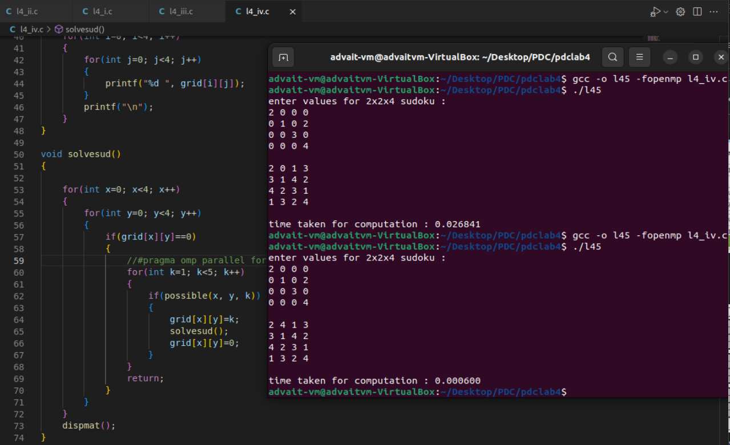

Code for Sudoku:

#include<stdio.h>
#include<omp.h>
#include<time.h>
#include<stdbool.h>

int grid[4][4]={{0, 0, 0, 0}, {0, 0, 0, 0}, {0, 0, 0, 0}, {0, 0, 0, 0}};

bool possible(int x, int y, int n)
{

for(int i=0; i<4; i++)
{
if(grid[x][i]==n)
return false;
}

for(int i=0; i<4; i++)
{
if(grid[i][y]==n)
return false;
}
int x0=(x/2)*2;
int y0=(y/2)*2;

for(int i=0; i<2; i++)
{
for(int j=0; j<2; j++)
{
if(grid[x0+i][y0+i]==n)
return false;
}
}

return true;
}

void dispmat()
{
printf("\n");
for(int i=0; i<4; i++)
{
for(int j=0; j<4; j++)
{
printf("%d ", grid[i][j]);
}
printf("\n");
}
}

void solvesud()
{

for(int x=0; x<4; x++)
{
for(int y=0; y<4; y++)
{
if(grid[x][y]==0)
{
//#pragma omp parallel for (enable in parallel)
for(int k=1; k<5; k++)
{
if(possible(x, y, k))
{
grid[x][y]=k;
solvesud();
grid[x][y]=0;
}
}
return;
}
}
}
dispmat();
}

void takevals()
{
for(int i=0; i<4; i++)
scanf("%d %d %d %d", &grid[i][0], &grid[i][1], &grid[i][2], &grid[i][3]);
}

int main()
{
clock_t t;
t=clock();

printf("enter values for 2x2x4 sudoku : \n");
takevals();
solvesud();
t=clock()-t;
double tt=((double)t/CLOCKS_PER_SEC);
printf("\ntime taken for computation : %f\n", tt);
}

